**WORLD TRADE CENTER**

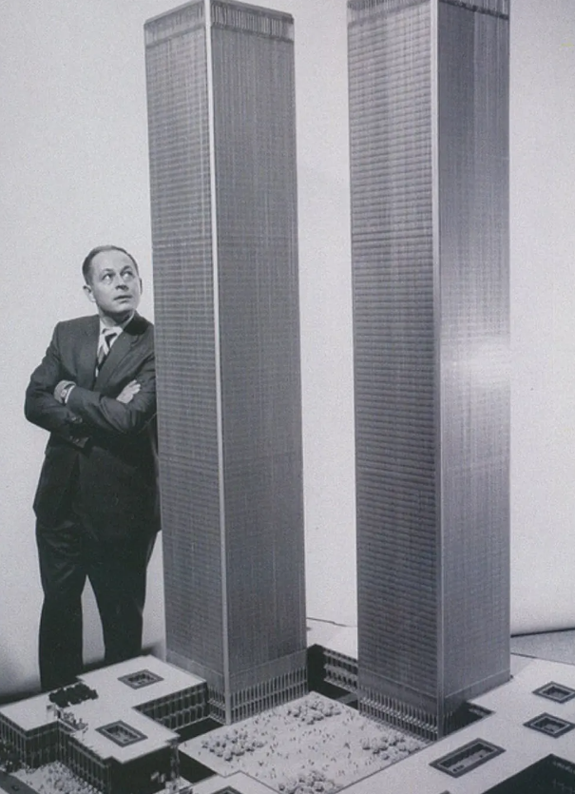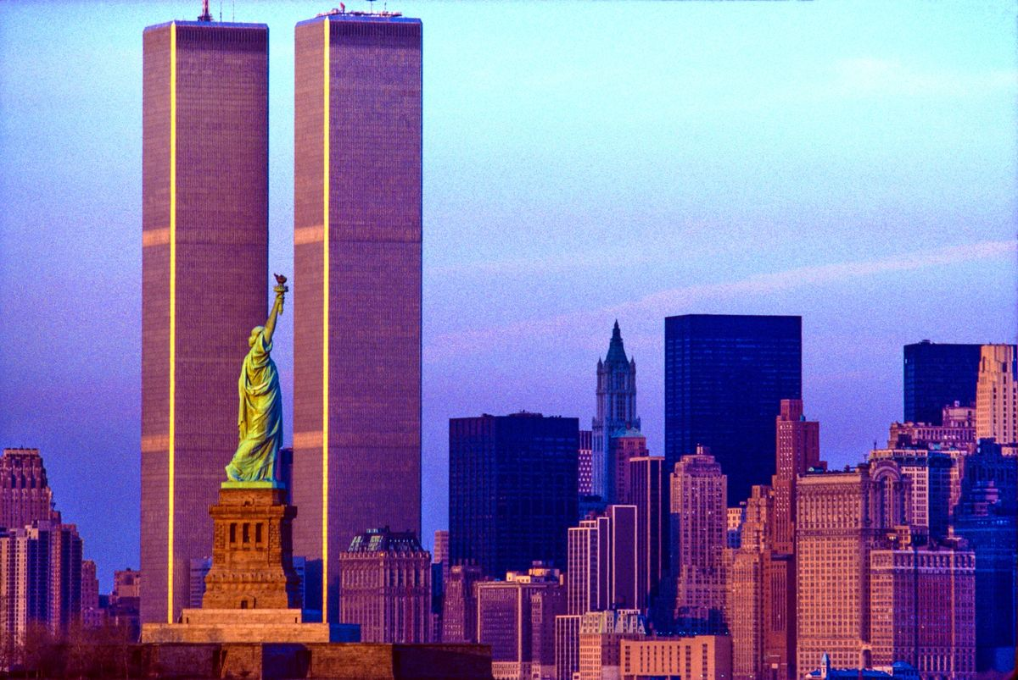

**GROUP MEMBERS**

LISHI DODUM (200104053)

NILESH KUMAR (200104069)

PRATEEK PARIHAR (200104080)

SUMIT KUMAR (200104109)

TUSHAR BHAKAT (200104113)

VIVEK SATTAWAN (200104118)

**PROJECT OVERVIEW**

The original ***World Trade Center****(****WTC****)* was a large complex of seven buildings in the Financial District of Lower Manhattan, New York City. It opened on April 4, 1973, and was destroyed in 2001 during the attack of 9/11 on Sept 11, 2001. At the time of their completion, the ***Twin Towers***—the original 1 World Trade Center (the North Tower) at 1,368 feet (417 m); and 2 World Trade Center (the South Tower) at 1,362 feet (415.1 m)—were the ***tallest building in the world***. Other buildings in the complex included the Marriott World Trade Center (3 WTC), 4 WTC,5 WTC,6 WTC, and 7 WTC. The complex contained 13,400,000 square feet (1,240,000 m2) of office space and, prior to its completion, was projected to accommodate an estimated 130,000 people. Below is the overview of the beginning, completion, and inauguration of each of the 7 WTC Skyscrapers:

**Start Date** **Completion** **Inauguration**

* 1 WTC: August 6, 1968 1972 Dec 15,1970
* 2 WTC: January 1969 April 4,1973 Jan 1972
* 3 WTC: March 1979 April 1,1981 July 1, 1981
* 4 WTC: 1974 1975 Jan 1977
* 5 WTC: 1970 1972 March 1972
* 6 WTC: 1969 1973 Jan 1974
* 7 WTC: October 2, 1984 March 1987 May 1987

Location of WTC: Lower Manhattan, New York City.

The idea of establishing a World Trade Center in New York City was first proposed in 1943. The New York State Legislature passed a bill authorizing New York Governor Thomas E. Devey to begin developing plans for the project, but the plans were put on hold in 1949. During the late 1940s and 1950s, economic growth in New York City was concentrated in Manhattan. To help stimulate urban renovation in Lower Manhattan, David Rockfeller suggested that the Port Authority build a World Trade Center there.

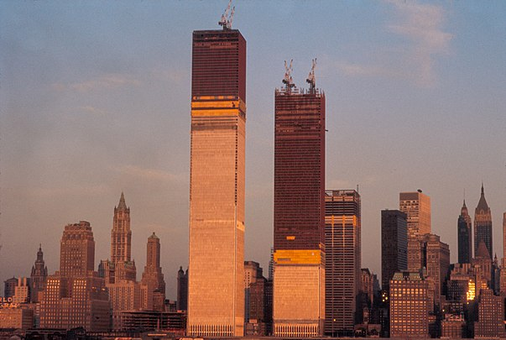

**CONTRACT DETAILS**

David Rockefeller suggested that ***the Port Authority*** would be a logical choice for taking on the project because it had experience with similar large engineering projects, and also because the Port Authority, rather than Rockefeller, would be paying for the complex's construction. Rockefeller argued that the Trade Center would provide great benefits in facilitating and increasing the volume of international commerce coming through the port of New York and New Jersey. David's brother, New York Governor Nelson Rockefeller, formally asked the Port Authority to investigate the feasibility of this proposal. Given the importance of New York City in global commerce, Port Authority director Austin J. Tobin remarked that the proposed project should be the World Trade Center and not just a generic "world trade center".Tobin commissioned an aide, Richard Sullivan, to lead a study on the feasibility of building a World Trade Center. **The Port Authority formally backed the project on March 11,1961**.

The core complex was built between 1966 and 1975, at a cost of ***$400 million*** ***(equivalent to $3.56 billion in 2022)***. The buildings at the complex were designed by ***Minoru Yamasaki*** as lead architect and ***Emery Roth and Sons*** as associate architects.

In January 1967, the Port Authority awarded $74 million in contracts to various steel suppliers.

***Tishman Realty and the construction company*** was the general contractor on the World Trade Center project.

**Engineers Involved**: The structural engineering firm Worthington, Skilling, Helle & Jackson worked to implement Yamasaki's design, developing the framed tubed structural system used in the twin towers. The Port Authority's Engineering Department served as Foundation engineers, Joseph R. Loring & Associates as electrical engineers, and Jaros, Baum, and Bolles as mechanical engineers. Guy F.Tozolli director of the World Trade Department at the Port Authority, and Rino M. Monti, the Port Authority's Chief Engineer, oversaw the project.

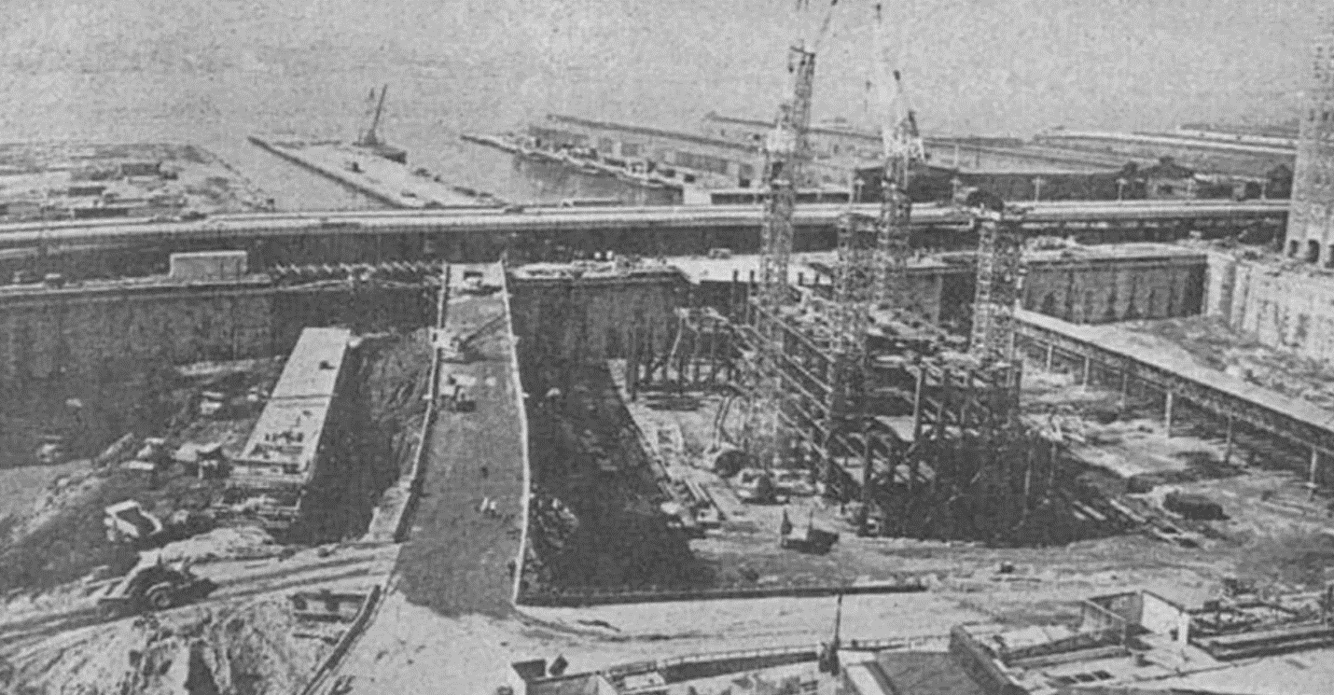

**TECHNIQUES ADOPTED IN THE PROJECT**

The construction of the **World Trade Center** involved several innovative techniques and methods. Some of them are:  
  
**1. Tube Structure**: The World Trade Center was designed using a tube structure, which consisted of a series of closely spaced steel columns and beams that formed a rigid frame. This design allowed the building to withstand high winds and seismic activity. The design of the Twin Towers is often called a "tube within a tube," referring to the fact that all the weight of the building was supported by the external walls and an internal column. Previously, the exterior walls of a skyscraper were called curtain walls.

**2. High-Strength Steel**: The steel used in the construction of the World Trade Center was of high strength, which allowed for thinner columns and beams,

**3. Slurry Wall Construction**: A slurry wall was constructed around the perimeter of the site to prevent water from seeping into the foundation. A trench dug deep in the ground was filled with a slurry mixture made from water and an expanding clay known as bentonite. This slurry was denser than the surrounding dirt, so it kept the ditch from caving in. Once filled with the mixture, a steel cage was dropped in that weighed 25 tons and stretched to a height of seven stories. Concrete was then poured into the trench. As the concrete was heavier than the slurry, it forced the clay mixture out and hardened around the cage, making a section of the underground wall. Workers then moved on to the next section. When the wall was complete, forming what became known as the "bathtub," the rest of the earth was removed from inside it without danger of flooding the newly opened space. This technique involved drilling deep trenches, filling them with a mixture of bentonite clay and water, and then inserting steel reinforcement cages before pouring concrete.

**4. Prefabrication**: Many of the building components were prefabricated off-site and then transported to the construction site. Prefabrication involves building parts of a structure off-site and then assembling them on-site. This technique was used for the towers' steel columns and trusses, which were fabricated off-site and then lifted onsite.

**5. Slip forming**: Slip forming is a continuous method of pouring concrete to form a structure. This technique was used in the construction of the towers' cores, which were poured continuously for several weeks.

**6. Fire Resistance**: Sprayed-fire-resistant materials (SFRMs) were used to protect some structural steel elements in the towers, including all floor trusses and beams. Gypsum Wallboard in combination with SFRMs, or in some cases gypsum wallboard alone, was used to protect core columns. Vermiculite plaster was used on the interior side and SFRMs were on the other three sides of the perimeter columns for fire protection.

Prior to the construction of the Twin Towers, skyscrapers were designed to support themselves through large internal columns spaced about 30 feet (9 meters) apart, which interrupted the flow of interior space. For this project however, the engineers came up with a different solution -- the exterior walls themselves would support the bulk of the structure, and they would get a boost from one single column of beams in the center.

To erect the tallest building in the world**, "kangaroo cranes"** were brought over from Australia. These mighty building machines could raise themselves up through the use of heavy-duty hydraulics, in effect growing with the building itself. The building of the Twin Towers marks the first time such cranes were used in America.

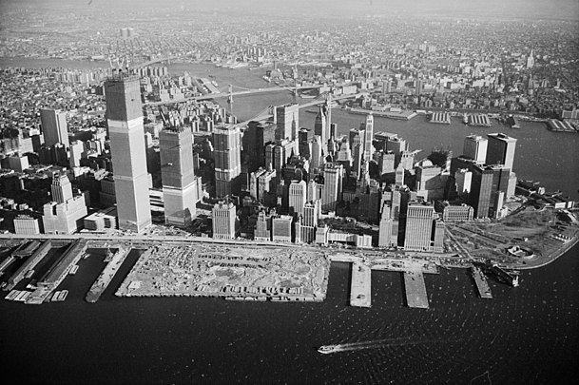 WTC 11 Jan ,1971

**EQUIPMENT USED**

The construction of the World Trade Center (WTC) complex in New York City was one of the largest and most complex building projects in history. The original WTC complex consisted of seven buildings, including the iconic Twin Towers, which were completed in 1973. The construction of the WTC required the use of a wide variety of equipment, ranging from cranes and bulldozers to specialized tools and machinery. In this report, we will discuss some of the key types of equipment used in the construction of the World Trade Center.

1. **Cranes:** Cranes were used extensively in the construction of the World Trade Center. Tower cranes were used to lift and position steel beams and concrete panels during the construction of the Twin Towers Mobile cranes were also used to move heavy equipment and materials around the construction site.
2. **Bulldozers and Excavators**: Bulldozers and excavators were used extensively to clear the site and prepare the foundation for the Twin Towers. These machines were used to remove debris, level the ground, and excavate the foundation.
3. **Concrete Pumps**: Concrete pumps were used to transport and pour concrete into the foundation and structural elements of the Twin Towers. These pumps allowed concrete to be poured at a high rate and with great precision, which was critical for the construction of the towers.
4. **Steel Fabrication Equipment**: The fabrication of the steel beams and other structural elements of the Twin Towers required specialized equipment, including welding machines, cutting tools, and bending machines. These machines were used to fabricate and shape the steel elements of the towers.
5. **Elevators:** The Twin Towers were equipped with some of the fastest and most advanced elevators in the world at the time of their construction. The elevators were essential for transporting workers and materials up and down the towers during construction.
6. **Power Tools:** Power tools, such as drills, saws, and grinders, were used extensively during the construction of the World Trade Center. These tools were used to cut and shape materials, install fixtures, and perform other tasks.
7. **Safety Equipment**: The construction of the World Trade Center was a dangerous and complex undertaking, and safety equipment was essential to protect the workers on the site. Safety equipment included hard hats, safety glasses, harnesses, and other protective gear.

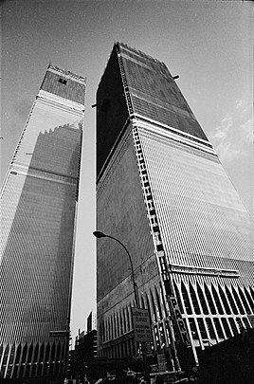View of World Trade Center,12 January 1971.

**CHALLENGES FACED AND THE PROBABLE STRATEGIES**

***CHALLENGE 1:***

The first major challenge was the building site itself. The location selected for the project, on Manhattan's Lower West Side, had been built upon generations of the landfill that had actually grown and compacted on itself so much that it had extended the Lower West Side of Manhattan into the Hudson River. To reach a solid base of bedrock, workers had to dig down 70 feet (21.3 meters). But because of the proximity of the river, a barrier needed to be created that would keep the excavated section of the city from filling with water as fast as the earth was removed.

***STRATEGY IMPLEMENTED:***

The answer was something that became known as the slurry trench method. A trench dug deep in the ground was filled with a slurry mixture made from water and an expanding clay known as bentonite. This slurry was denser than the surrounding dirt, so it kept the ditch from caving in. Once filled with the mixture, a steel cage was dropped in that weighed 25 tons and stretched to a height of seven stories. Concrete was then poured into the trench. As the concrete was heavier than the slurry, it forced the clay mixture out and hardened around the cage, making a section of the underground wall. Workers then moved on to the next section. When the wall was complete, forming what became known as the "bathtub," the rest of the earth was removed from inside it without danger of flooding the newly opened space.

***CHALLENGE 2:***

Another concern unique to the construction of the World Trade Center was the fact that the PATH commuter rail line ran directly through the center of the construction site.

***STRATEGY IMPLEMENTED:***

Instead of interrupting service, engineers designed a protective cradle for the underground line and as a result, the train ran throughout the entire project, carrying 130,000 passengers a day

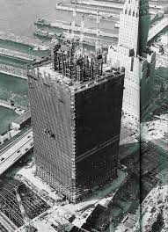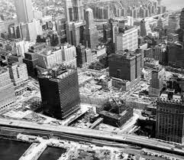

**IMPLEMENTATION OF ICT AND AUTOMATION**

The construction of the World Trade Center (WTC) took place from the late 1960s to the early 1970s, and during this time, information, and communication technology (ICT) and automation were not as advanced as they are today. However, there were still some instances where technology was implemented in the construction of the WTC. Here are some examples:

1. **Computer-aided design (CAD)**: The design of the World Trade Center towers was done using CAD technology, which was relatively new at the time. This allowed the architects and engineers to create more accurate and detailed designs, and to make changes more quickly and easily.
2. **Elevator automation**: The World Trade Center towers were equipped with some of the fastest elevators in the world at the time, which were controlled by an automated system. This allowed for efficient and speedy movement of people and materials throughout the buildings.
3. **Communication systems**: The World Trade Center was equipped with an advanced communication system that included intercoms, public address systems, and emergency call buttons. This allowed for quick and efficient communication between workers and emergency personnel in case of an emergency.
4. **Material handling**: The construction of the WTC involved the use of cranes and other heavy equipment to move materials and equipment. Some of these cranes were equipped with automation technology, which allowed for more precise movements and improved safety.

While the use of ICT and automation in the construction of the World Trade Center was limited by today's standards, it still represented a significant step forward at the time and helped to make the construction process more efficient and effective.

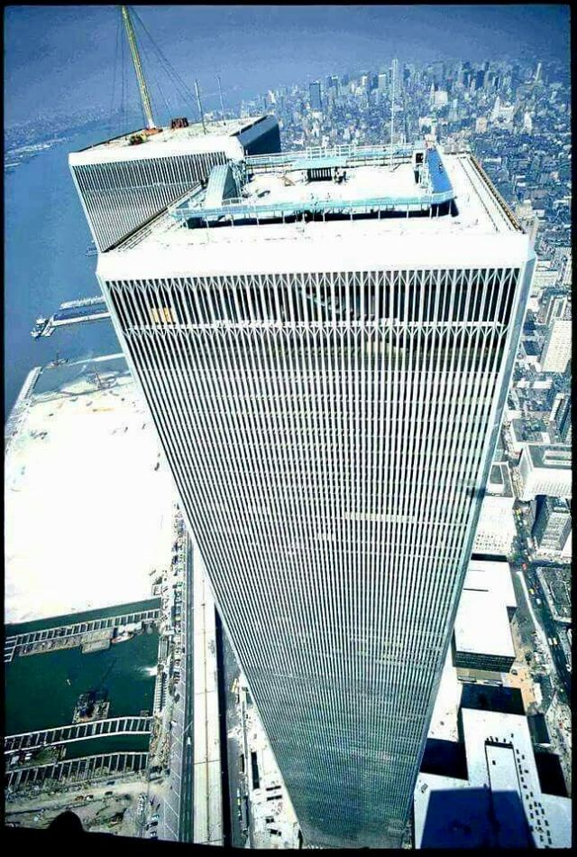

**PROJECT PERFORMANCES**

**Project Duration**:

In March 1965, the Port Authority began acquiring property at the World Trade Center site. Demolition work began on March 21, 1966, to clear thirteen square blocks of low-rise buildings in Radio Row for its construction. Groundbreaking for the construction of the World Trade Center took place on August 5, 1966. About two years of prep work was then needed to prepare the site for the construction of the towers. Construction work began on the North Tower in August 1968, and construction on the South Tower was underway by January 1969. The topping out ceremony of 1 WTC (North Tower) took place on December 23, 1970, while 2 WTC's ceremony (South Tower) occurred on July 19, 1971. In addition to the twin towers, the plan for the World Trade Center complex included four other low-rise buildings, which were built in the early 1970s. The 47-story 7 World Trade Center building was added in the 1980s, to the north of the main complex. **The WTC 1 took 11 years to complete**.

**Safety:**

Structural and fireproofing materials:

The major structural material employed in the towers was ***A36 structural steel***, although higher-strength steel was used in the lower elevations of the structure. Except for some selected floors, for which normal strength concrete was employed, the composite slabs were made of ***21MPa (3ksi) lightweight concrete***. Fire resistance of the perimeter columns was provided by a layer of sprayed concrete around the three sides of each column. The concrete layer had a thickness of about 5cm and included ceramic fibers in the mix. The interior face of each column was fire protected with an approximately ***5cm thick layer of vermiculate plaster***. The exterior sides of each perimeter column were covered by aluminum to which the window frames were fixed. It has been reported that passive fire protection was provided to the underside of the floor systems by a ***fire-rated suspended ceiling***. Specifics of fireproofing implemented on these buildings including which structural members were treated and to what level of fire resistance are still being investigated.

**Project Cost**:

The core complex was built between 1966 and 1975 the cost was **400$ million.**

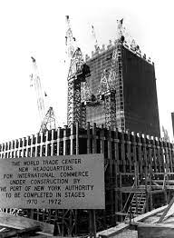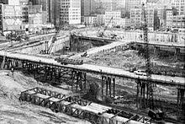

**PROJECT DISPUTES AND THEIR SETTLEMENT**

The construction of the World Trade Center (WTC) was a massive undertaking that involved numerous project disputes. Here are some of the significant disputes that occurred during the construction of the WTC:

1. **Cost Overruns**: The initial budget for the WTC was **$350 million**, but the final cost **exceeded $1 billion**. The Port Authority of New York and New Jersey, which owned the site, faced criticism for overspending and mismanagement.
2. **Design Changes**: The original design for the WTC included a lattice-like facade that was later changed to a smooth glass exterior. This change led to disputes between the architects and the Port Authority, as the architects argued that the change would compromise the building's structural integrity.
3. **Labor Disputes**: The construction of the WTC was plagued by labor disputes, with workers demanding better pay and working conditions. In 1970, a strike by ironworkers and crane operators halted construction for several weeks.
4. **Environmental Concerns:** The construction of the WTC led to environmental concerns, as the excavation of the site released large amounts of pollutants into the air and nearby waterways. The Port Authority was criticized for not taking adequate measures to address these concerns.
5. **Controversial Construction of WTC**: Plans to build the World Trade Center were controversial. Its site was the location of Radio Row, home to hundreds of commercial and industrial tenants, property owners, small businesses, and approximately 100 residents, many of whom fiercely resisted forced relocation. A group of affected small businesses sought an injunction challenging the Port Authority's power of an eminent domain. The case made its way through the court system to the US Supreme Court; which refused to hear the case.
6. **Aesthetics Criticism**: The World Trade Center's design aesthetics attracted criticism from the American Institute of Architects and other groups. Lewis Mumford, the author of “The City of History” and other works on urban planning, criticized the project, describing it and other new skyscrapers as "just glass-and-metal filing cabinets”. The Twin Towers were described as looking like "the boxes that the Empire State Building and the Chrysler Building came in”. *Many disliked the twin towers' narrow office windows, which were only 18 inches (46 cm) wide* and framed by pillars that restricted views on each side to narrow slots. Activist and sociologist Jane Jacobs argued that the waterfront should be kept open for New Yorkers to enjoy.
7. **Inhospitable Environment**: Some critics regarded the trade center's "superblock", replacing a more traditional dense neighborhood, as an inhospitable environment that disrupted the complicated traffic network typical of Manhattan. For example, in his book “The Pentagon of Power”, Lewis Mumford denounced the center as an "example of the purposeless giantism and technological exhibitionism that are now eviscerating the living tissue of every great city".
8. **Suicide Concerns**: Issues were raised regarding the risks of suicides if such a huge construction of 107 floors was taken into consideration.

To counter that issue an anti-suicide fence was placed on the roof itself, with the viewing platform set back and elevated above it, requiring only an ordinary railing. This left the view unobstructed, unlike the observation deck of the Empire State Building.

1. **Delay at the beginning of construction**: Hold on to the establishment of the World Trade Centre: The idea of establishing a World Trade Center in New York City was first proposed in 1943. The New York State Legislature passed a bill authorizing New York Governor Thomas E. Dewey to begin developing plans for the project, but the plans were put on hold in 1949. This was because the market established there was to be removed. To compensate Radio Row business owners for their displacement, the Port Authority gave each business $3,000 without regard to how long the business had been there or how prosperous it was. The Port Authority began purchasing properties in the area for the World Trade Center by March 1965, and the demolition of Radio Row began in March 1966. It was demolished by the end of the year.

**CONCLUSION**

Overall, the construction of the World Trade Center was a complex project that involved numerous parties and led to several disputes. Despite these challenges, the WTC was completed and became an iconic symbol of New York City until the tragic events of September 11, 2001.

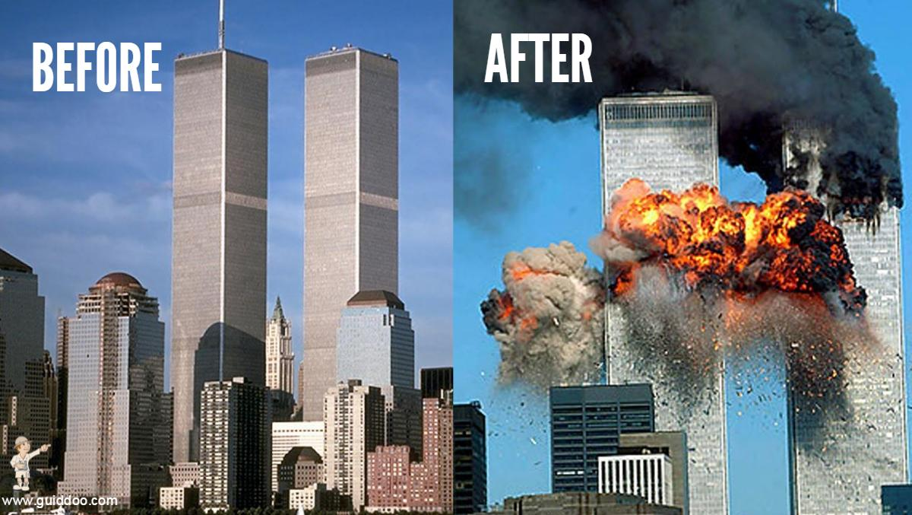

Top of Form